Contract Agreement for App Development

Company: HMF, Home Made Food. [Healthy food service] incorporated under the laws of India.

Developer : Vekariya Parthiv Vajubhai , Resigning at S/O Vajubhai, Ambardi, POn: Gondal, District : Rajkot. He is an independent contractor

1. Project Scope:

The developer will develop a mobile app for [ Home Made Food ] based on the following specifications:
[ HMF ]
[Brief description: Platform to serve home made healthy and fresh food in reasonable rate to the society via an online platform.]
[Target platforms: iOS and Android both]

2. Deliverables:
The developer will deliver the configuration which he has mentioned.

3. Timeline:

The project will be completed by End of the October, 2024.
The developer will provide regular updates on project progress.

4. Compensation:

The Company will pay the Developer a total of [ Twenty thousand INR.] for the project as a Full and final Payment for entire App as discussed and Required for the Project.

5. Intellectual Property:
The Developer will leave the rights of the source code and intellectual property created for the project and hand over to us without any Copyright.
The Company will have a non-exclusive, worldwide license to use the app and its deliverables.

6. Confidentiality:
Both parties agree to maintain confidentiality regarding the project and its related information.

7. Termination:
Either party may terminate the agreement for cause with 2 days' written notice.
In case of termination, the Developer will deliver all completed or incomplete work to the Company.

8. Governing Law:

This agreement shall be governed by and in accordance with the laws of India. Subject to Ahmedabad, Gujarat Jurisdiction .

9. Dispute Resolution:
Any disputes arising from this agreement shall be resolved through [Dispute resolution method, e.g., negotiation, mediation, arbitration].

10. Entire Agreement:
This agreement constitutes the entire understanding between the parties.

[ Home Made Food ]
Authorised person.
Date: 31/8/24

[Developer]
Sign: 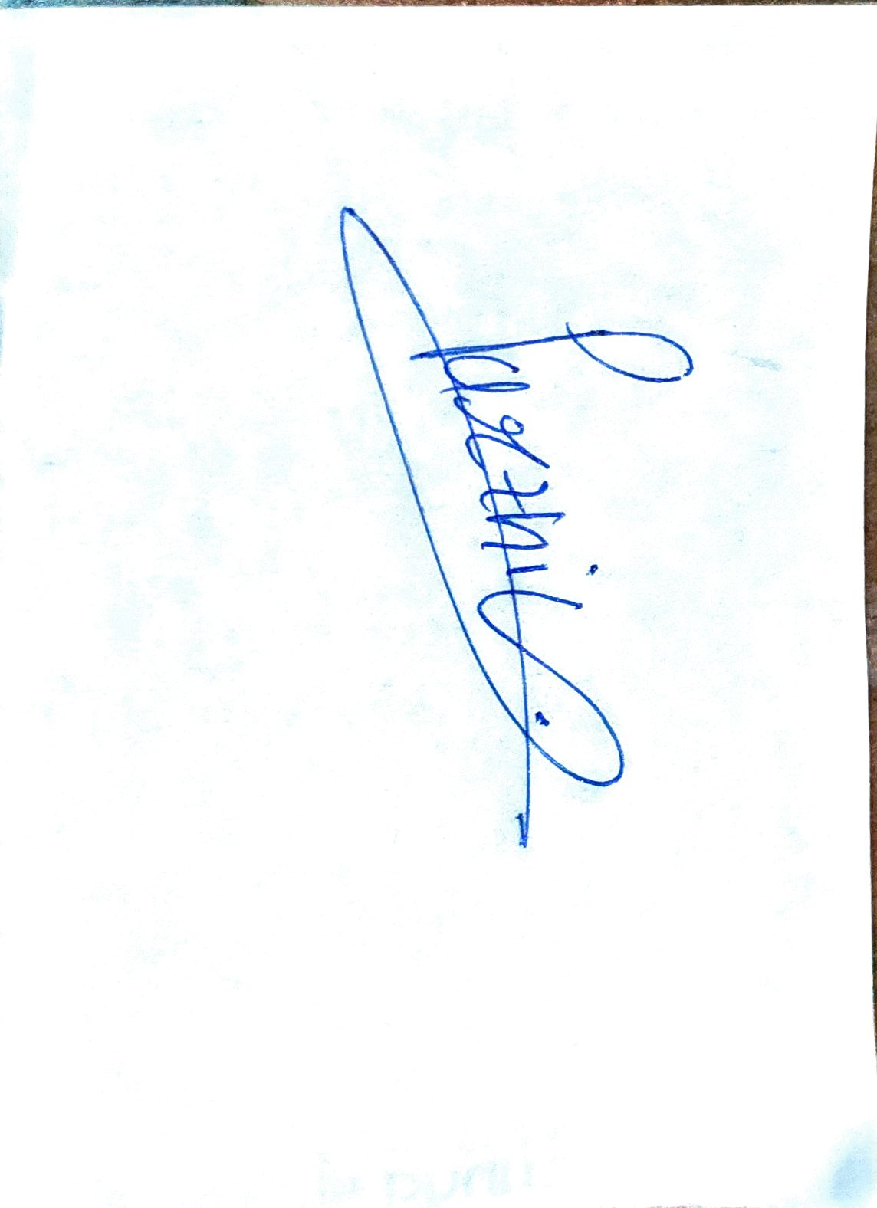
Date: [1/9/2024]

Gemini may display inaccurate info, including about people, so double-check its responses. Your privacy and Gemini AppsOpens in a new window

